VPC endpoint lab
- Create one VPC
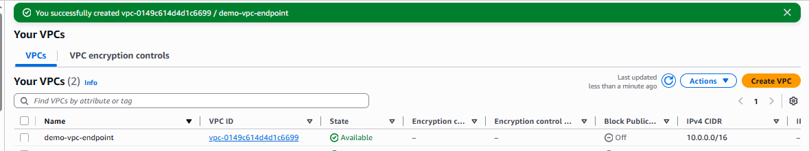
- Then create two subnet(private sub and public sub) with custom VPC which we have create above.
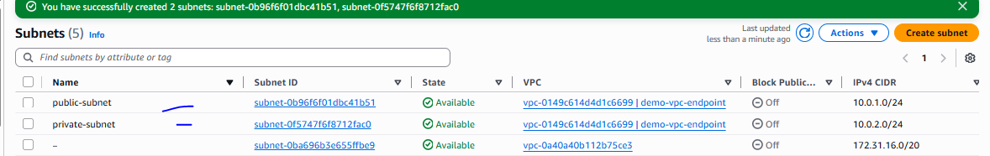

- Then create Internet Gateway to attach the custom VPC
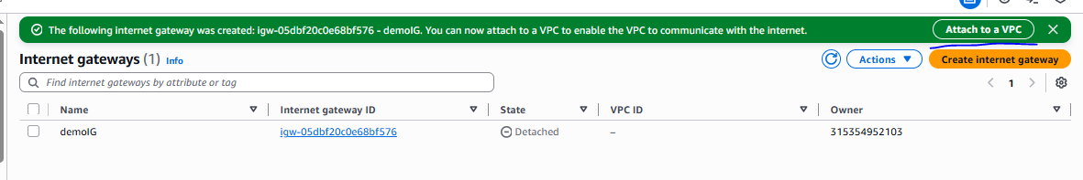
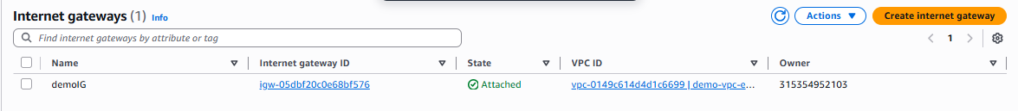
- Create a nat gatway in zonal to attach the public subnet for routing to private subnet.
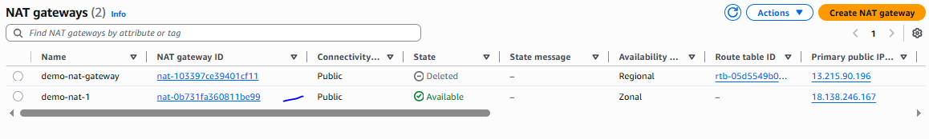
- Create two route table(one for public subnet and second for private subnet), once create the route table public route table do routing to internet gateway with all IP and subnet association to public subnet similarally private route table routing the NAT gateway with all IP and subnet association to private subnet
Two route table has been created
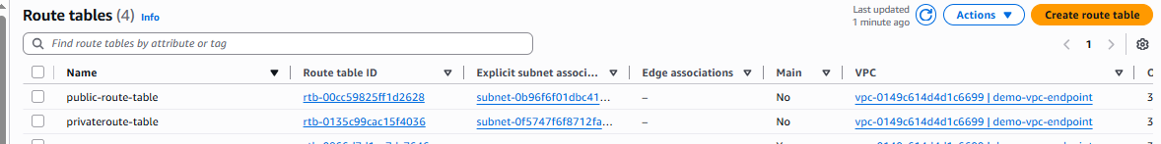

- Before creating the VPC end point need to create the one S3 bucket
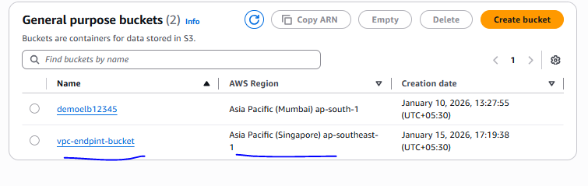
- Create one vpc end point as mention below
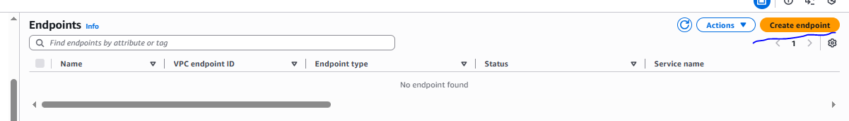
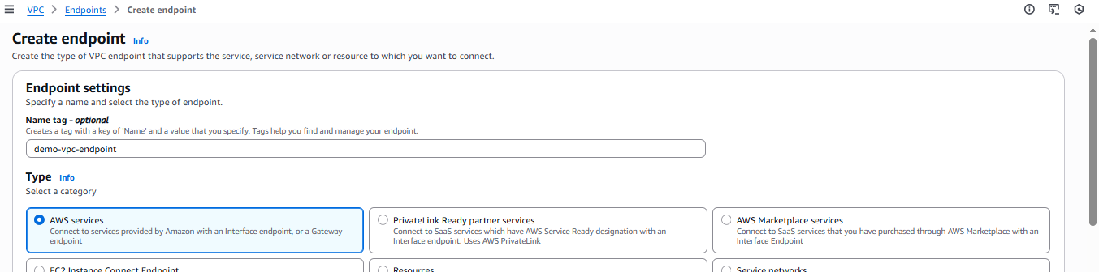
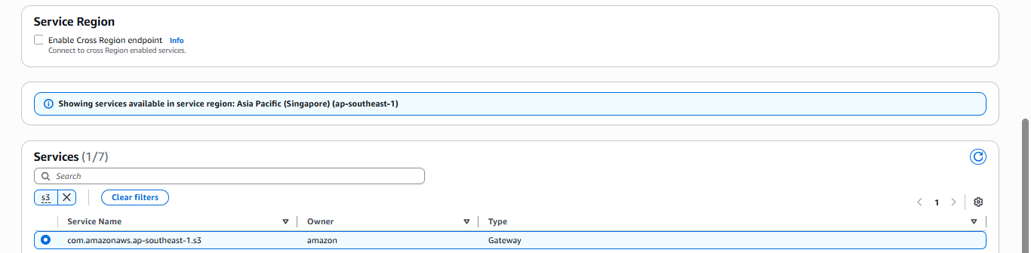
Need to select private route table because need to access any bucket in private subnet
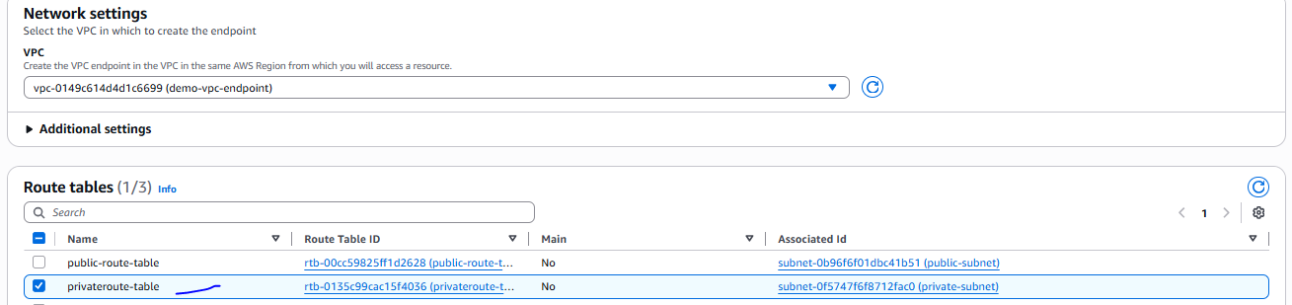

VPC end point has been created with gateway
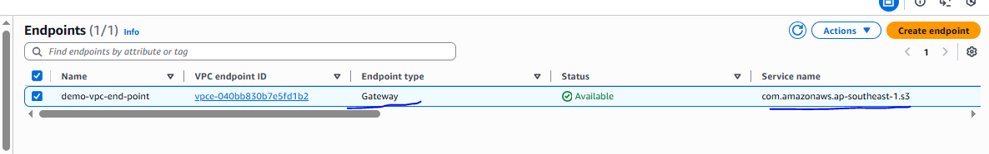
- Create two instance with one is a private subnet and one is public subnet and both should be with the IAM s3 full access admin role
Need to change below setting
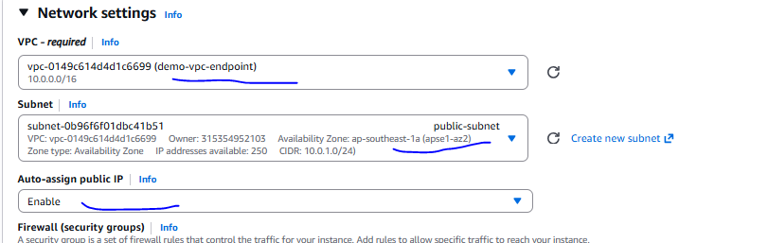
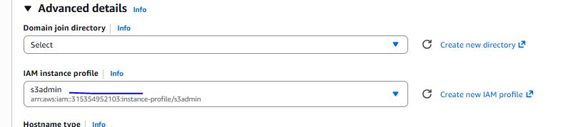
Both instance has been created
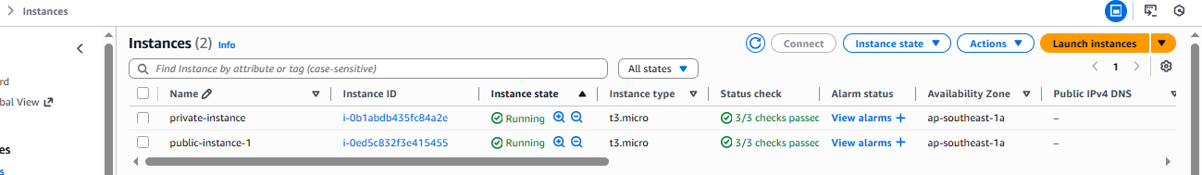
Verification
- Need to login public subnet server

Able to login public subnet instance and also able to connect network and also able to connect S3 bucket
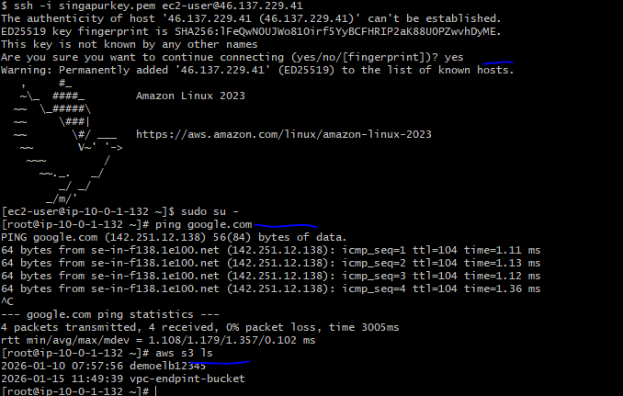
B) need to login private subnet instance with NAT gateway and with private IP
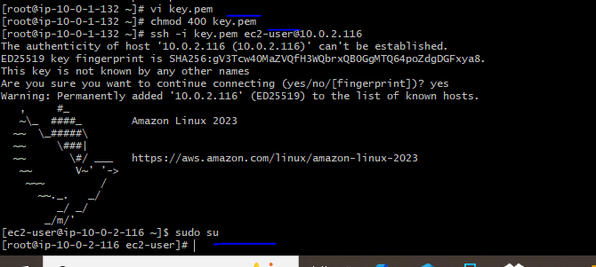

Able to connect network due to the NAT gateway and also able to connect S3
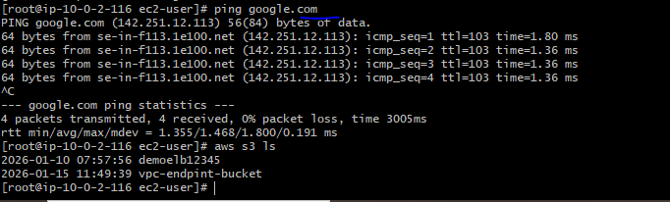
C) Need to verify without internet connect means remove the NAT gateway from private route table from routing
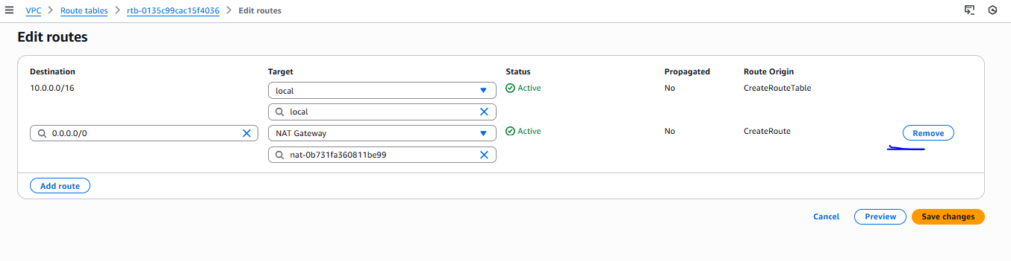
Once remove the NAT gateway not able to connect network but able to connect s3
